**CREATIVITY AND INNOVATION**



BELG 0001

Institute of Engineering & Technology

B. TECH(CS) HONORS (2022-23)

Submitted By Submitted To

Shiva Srivastava Dr. Nirbhay Kumar Mishra (2115800023) Associate Professor

**Department of Computer Engineering & Applications**

**1st Week Progression**

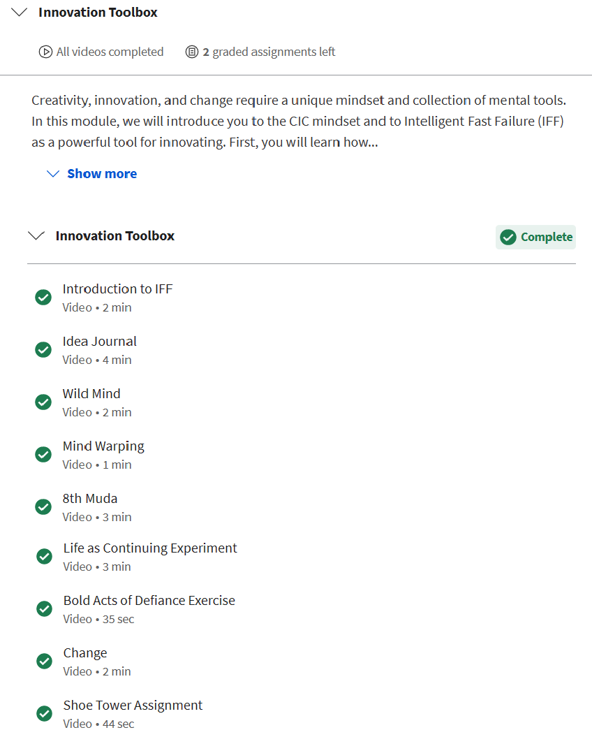

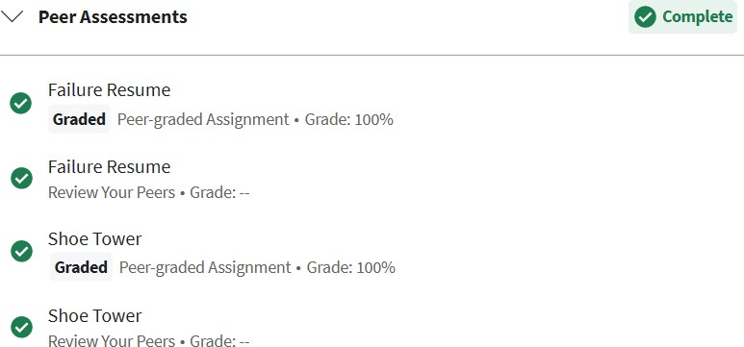

**Notes**

* [**Introduction to IFF**](https://www.coursera.org/learn/creativity-innovation/lecture/QQcBC?t=126)

**Your Notes**

**4 Points**

* Intelligent Fast Failure (IFF) is a methodology that combines the principles of creativity and innovation with the idea of rapid experimentation and quick decision-making. This approach encourages organizations to embrace failure as an opportunity to learn and grow, rather than a setback or a mistake.
* In the context of creativity and innovation, IFF encourages teams to generate and test new ideas quickly and cheaply, with the goal of identifying the most promising ideas as early as possible. This approach is based on the understanding that not all ideas will be successful, and that failure is a necessary part of the innovation process.
* The key to IFF is to be intelligent about the way failures are managed. Instead of simply accepting failure as an inevitable part of the process, IFF encourages teams to analyze and learn from failures so that they can improve future iterations. This requires a culture of openness and transparency, where failures are viewed as opportunities to learn and grow, rather than as something to be hidden or avoided.
* IFF can help teams generate and test new ideas quickly and effectively. By embracing failure as a necessary part of the process, teams can learn from their mistakes and iterate more quickly, ultimately leading to more successful innovations.

Overall, IFF is a powerful methodology that can help organizations foster a culture of innovation and creativity. By encouraging teams to embrace failure as an opportunity to learn and grow, IFF can help organizations stay ahead of the competition and drive long-term success.

* [**Idea Journal**](https://www.coursera.org/learn/creativity-innovation/lecture/8Tctx?t=0)

**Your Notes**

* An idea journal is a tool used to capture and record creative ideas as they come to mind. It is a valuable resource for individuals and teams who are looking to develop their creativity and innovation skills.
* One of the key benefits of using an idea journal is that it allows individuals to capture ideas as they occur, rather than relying on memory. When we have a creative idea, it is often fleeting and can easily be forgotten. By recording ideas in an idea journal, individuals can capture and retain their ideas for future reference and exploration.
* In the context of creativity and innovation, an idea journal is particularly important because it encourages individuals to generate and record new ideas regularly. By making a habit of recording ideas, individuals can train their minds to think more creatively and to come up with new and unique ideas on a regular basis.

[**Wild Mind**](https://www.coursera.org/learn/creativity-innovation/lecture/uoZsW?t=5)

.**Your Notes**

* Wild Mind is a concept in the field of creativity and innovation that refers to the untamed and free-flowing nature of the creative process. It is a term that suggests the idea of breaking free from conventional thinking patterns and allowing the mind to wander and explore without constraints.
* In the context of creativity and innovation, the concept of Wild Mind encourages individuals to embrace their inner creativity and to be open to new and unconventional ideas. It is a way of thinking that encourages individuals to explore ideas and solutions that may not seem immediately practical or feasible, but that may lead to breakthrough innovations.
* The concept of Wild Mind is often associated with creativity techniques such as brainstorming, mind mapping, and free writing. These techniques encourage individuals to let their minds wander freely, without judging or evaluating their ideas, and to explore new and unusual connections between different concepts and ideas.
* The concept of Wild Mind is also closely linked to the idea of divergent thinking, which is the ability to generate multiple solutions to a problem. In the context of creativity and innovation, divergent thinking is a key skill that allows individuals to explore a wide range of potential solutions, rather than simply accepting the first idea that comes to mind.

[**Mind Warping**](https://www.coursera.org/learn/creativity-innovation/lecture/BM9Ey?t=0)

**Your Notes**

* Mind warping is a concept in the field of creativity and innovation that refers to the intentional manipulation of one's thinking patterns in order to generate new and innovative ideas. It is a technique that encourages individuals to break free from conventional thinking patterns and explore new and unconventional ideas.
* In the context of creativity and innovation, mind-warping techniques are used to challenge and disrupt traditional ways of thinking, in order to generate breakthrough ideas and solutions to complex problems. These techniques can include activities such as reverse thinking, scenario planning, and forced connections, among others.

[**8th Muda**](https://www.coursera.org/learn/creativity-innovation/lecture/Vvt5P?t=4)

**Your Notes**

* The 8th Muda is a concept in the field of creativity and innovation that refers to the "waste of unused human creativity and talent." It is a term used to describe the lost potential that results from not utilizing the creativity and innovative potential of individuals within an organization.
* In the context of creativity and innovation, the 8th Muda highlights the importance of fostering a culture of creativity and innovation within an organization. It suggests that failing to tap into the creative potential of employees can result in missed opportunities for innovation and growth.
* To address the 8th Muda, organizations can take steps to encourage and support creativity and innovation among employees. This can include providing training and resources to help employees develop their creativity and innovation skills, as well as creating a supportive culture that encourages experimentation and risk-taking.

[**Life as Continuing Experiment**](https://www.coursera.org/learn/creativity-innovation/lecture/3r3DM?t=4)

**Your Notes**

* The concept of life as a continuing experiment refers to the idea that life is an ongoing process of experimentation and exploration. This concept is closely linked to the field of creativity and innovation, as it suggests that individuals should approach life with a sense of curiosity and openness to new experiences.
* In the context of creativity and innovation, the idea of life as a continuing experiment encourages individuals to embrace failure as a natural part of the creative process. It suggests that experimentation and trial and error are necessary components of the creative process, and that failure should be viewed as an opportunity for growth and learning.
* The concept of life as a continuing experiment also highlights the importance of adaptability and resilience in the face of change. It suggests that individuals should be open to new ideas and experiences, and should be willing to adapt and change in response to changing circumstances.

[**Change**](https://www.coursera.org/learn/creativity-innovation/lecture/rdnhX?t=0)

**Your Notes**

* Change is a key component of creativity and innovation, as it is often the catalyst for new ideas and breakthrough solutions to complex problems. In the context of creativity and innovation, change refers to the process of introducing new ideas, approaches, and technologies in order to improve products, services, and processes.

**Discussions**

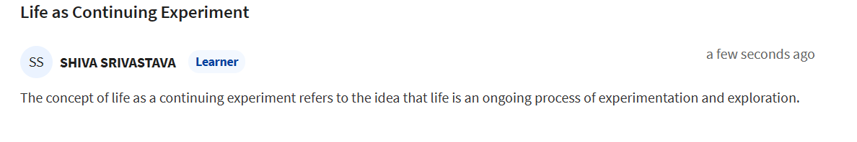

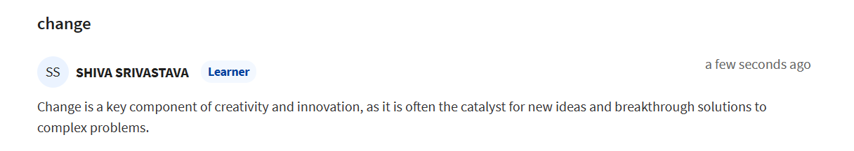

**Peer Assessment**

**Failure Resume**

You may enter your Failure Resume in the text box below or upload a PDF in the next field.

Failure of my Life :

1)when I was in 9th class and trying to learn and understand Mathematics at the beginning I ga of failure to pass a simple class test But after this failure, I again and again try and now I am a Mathematics Lover.

2)In the 10th class, I was trying to shift my education to online mode. And I got not quite a good result, therefore relative, parents and teachers think it happens only because you take a risk to learn online. But I never give up I had learned 12th from the online education platform and I got pretty good results.

3)Now again I take a risk to prepare JEE examination online mode again I got a failure but I learned different methods to accommodate myself in an online way.

4)Since, I am from a rural area, therefore, I did not know every person has different behavior, and nature and might be not trustworthy. But from 1st to 3rd semester in my college I believed in everyone and get connected to that person, that's why I got a lot of sadness, and if I simply told this quite a bad experience in society. But now I learned how to accommodate society.

5)In college time, I don't know what is Love, and friendship and how they affect you. But I also fall in that, I got some failures in that, from this failure, I become a more intellectual person who can tackle any problem. Now I clearly understand Who I am, How people can think about me, what should you do and what should you not do for that.

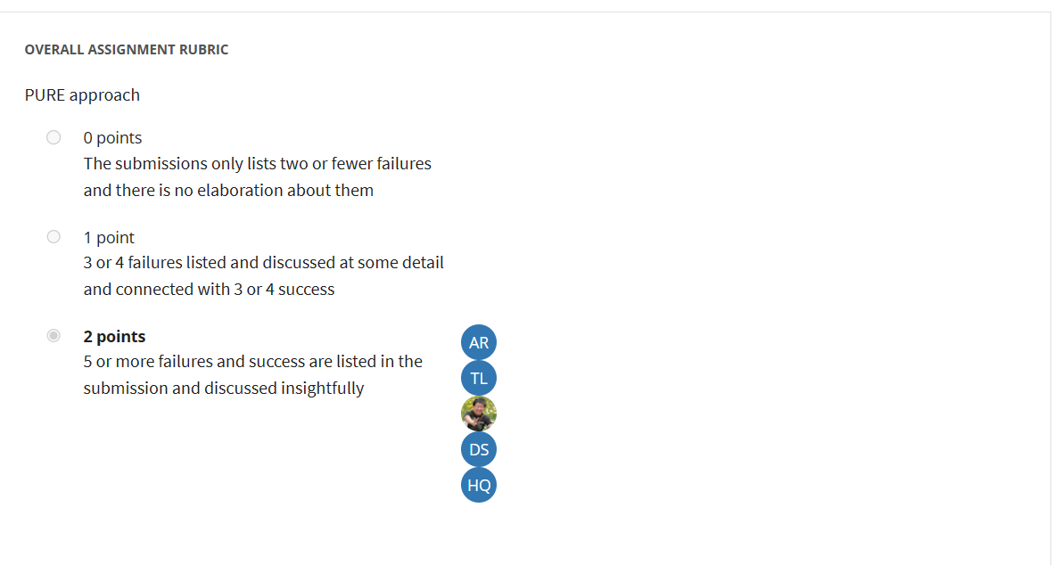

**Shoe tower Assignemnt.**

**To make the problem more challenging, you must also rate your tower using the following formula. See how high a “T value” you can achieve using the “T formula” below. (Note – The T value has nothing to do with a grade for the exercise.)**

The T formula: T = (Total tower height in cm) divided by (Number of shoes).

**Concept of Science and Mathematics:**

1) Here we are try to hold shoes by the help of Friction.

2)By the help of Center of Mass

**Please provide a detailed description of the process you went through to build your Shoe Tower. What did you learn from completing the assignment?**

**Process:**

Take shoes by the help of centre of mass hold other.

just put one shoes on other by balancing center of mass with the help of friction.

**How many attempts/failures/revisions did you make in building your Shoe Tower?**

**Failure :**

I got 20 times failure, from first 10 make triangle to give base so that it can hold heavy things at top.

after 10 attempts I got position of center of mass of shoes.

In 21 attempt I got success

**How tall was your Shoe Tower (in cm)?**

How many shoes did you use? What is the T-value for your towers? Remember: T-value = (height in cm) / (number of shoes).

My Shoes is 1.2 feet tall.

here, we got height by calculating height of triangle formed using shoes in each level.

and then add them

**Height Calculation:**

in my scenario two triangle set is formed.

we are using Pythagoras theorem

p - is height of set of triangle

b - base of right angle triangle

h- height of shoes in each level

**h^2=p^2+b^2**

we got h1 and h2

then T=h1+h2

**How beautiful was your Shoe Tower (rate it on a scale from 1 to 10, with 10 being the most beautiful)? How did you assess this value -- by comparison, by survey, from friends?**

**Beautiful:**

If i go with respect to beauty of science and mathematics it got 9 out of 10.

**Where would you put yourself on a creativity scale from 1-10 (10 being the most creative) for this assignment?**

What creativity value do you want to reach for yourself?

**Creative**

I think i put myself as 6 out of 10 in creativity.

**Class Quiz**

**Presentation on Creativity and Innovation**



